1. Design FIR Low pass filter having cutoff frequency 3 KHz, N=31; Sampling frequency=10 KHz
2. Design FIR High pass filter having cutoff frequency 3 KHz, N=31; Sampling frequency=10 KHz
3. Design FIR Band pass filter having cutoff frequency (3 KHz, 6 KHz) N=31; Sampling frequency=10 KHz
4. Design FIR Band stop filter having cutoff frequency (3 KHz, 6 KHz) N=31; Sampling frequency=10 KHz

Code:-
# write a python program to design FIR low pass, high pass, band pass and band stop filters

import numpy as np
import matplotlib.pyplot as plt
from scipy.signal import firwin, freqz

N = 31 # number of filter coefficients (taps)
fs = 10000 # sampling frequency in Hz

# Function to display the frequency response of a filter
def plot_response(h, fs, title):
w, H = freqz(h, worN=1024, fs=fs)

plt.figure(figsize=(10, 4))

plt.subplot(1, 2, 1)
plt.plot(w, abs(H))
plt.title(title)
plt.xlabel('Frequency (Hz)')
plt.ylabel('Magnitude')
plt.grid(True)

plt.subplot(1, 2, 2)
plt.plot(w, 20 * np.log10(abs(H) + 1e-10))
plt.title('Magnitude in dB')
plt.xlabel('Frequency (Hz)')
plt.ylabel('Magnitude (dB)')
plt.ylim(-100, 5)
plt.grid(True)

plt.tight_layout()
plt.show()

1. FIR Low pass filter (cutoff = 3 kHz)
cutoff = 3000
h_lp = firwin(N, cutoff, fs=fs) # hamming window is used by default

print("Filter coefficients:")
print(np.round(h_lp, 4))

plot_response(h_lp, fs, 'FIR Low Pass Filter (Cutoff = 3 kHz)')

Output:-
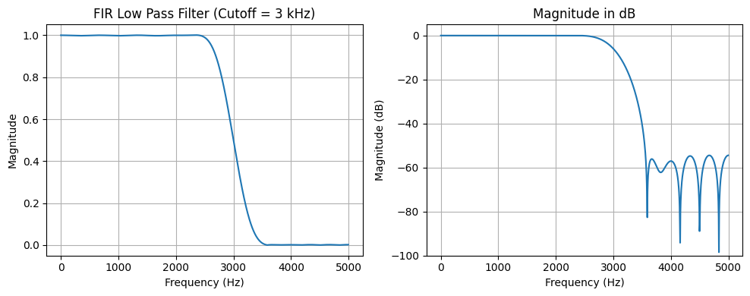

2. FIR High pass filter (cutoff = 3 kHz)
cutoff = 3000
h_hp = firwin(N, cutoff, pass_zero=False, fs=fs)

print("Filter coefficients:")
print(np.round(h_hp, 4))

plot_response(h_hp, fs, 'FIR High Pass Filter (Cutoff = 3 kHz)')

Output:-
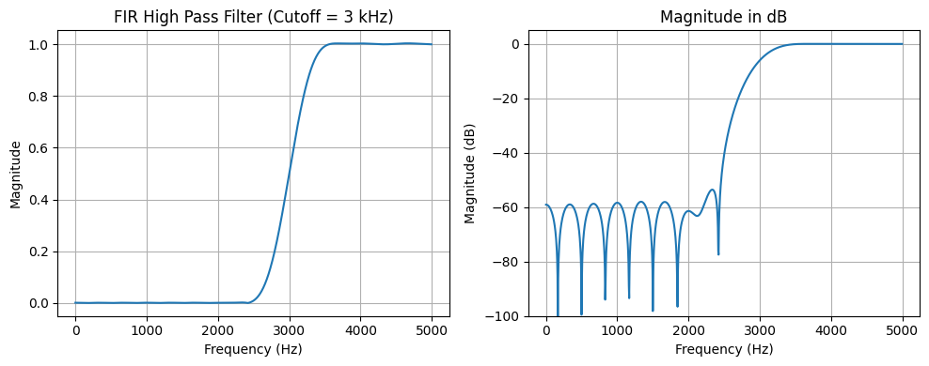

3. FIR Band pass filter (cutoff = 3 kHz, 6 kHz)
Note: With fs = 10 kHz the Nyquist frequency is 5 kHz, so the upper cutoff of 6 kHz is not possible. The band 3 - 6 kHz is limited to 3 - 5 kHz, so the filter works as a high pass filter. A second design with fs = 20 kHz is given to show the real band pass filter.
# fs = 10 kHz : upper cutoff 6 kHz is above Nyquist (5 kHz), so only 3 kHz is used
h_bp1 = firwin(N, 3000, pass_zero=False, fs=fs)

print("Filter coefficients (fs = 10 kHz):")
print(np.round(h_bp1, 4))

plot_response(h_bp1, fs, 'Band Pass (3-6 kHz), fs = 10 kHz')

Output:-
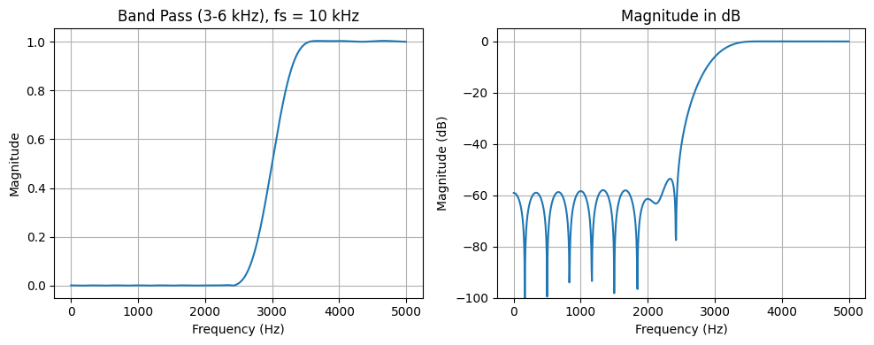

# fs = 20 kHz : both cutoffs 3 kHz and 6 kHz are valid
fs2 = 20000
h_bp2 = firwin(N, [3000, 6000], pass_zero=False, fs=fs2)

print("Filter coefficients (fs = 20 kHz):")
print(np.round(h_bp2, 4))

plot_response(h_bp2, fs2, 'FIR Band Pass Filter (3-6 kHz), fs = 20 kHz')

Output:-
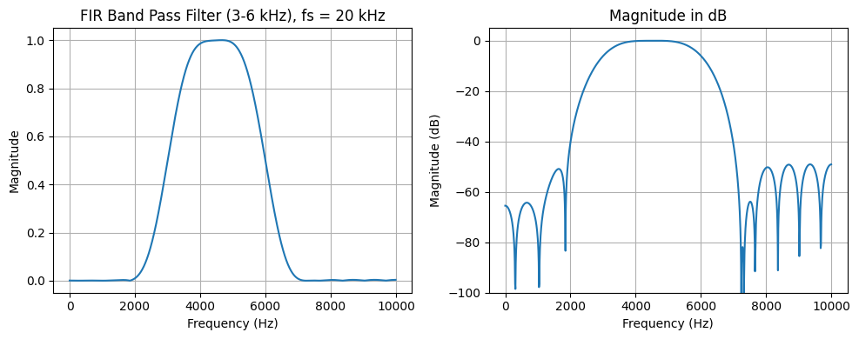

4. FIR Band stop filter (cutoff = 3 kHz, 6 kHz)
Note: For the same reason, with fs = 10 kHz the stop band 3 - 6 kHz is limited to 3 - 5 kHz, so the filter works as a low pass filter. The real band stop filter is designed with fs = 20 kHz.
# fs = 10 kHz : upper cutoff 6 kHz is above Nyquist (5 kHz), so only 3 kHz is used
h_bs1 = firwin(N, 3000, fs=fs)

print("Filter coefficients (fs = 10 kHz):")
print(np.round(h_bs1, 4))

plot_response(h_bs1, fs, 'Band Stop (3-6 kHz), fs = 10 kHz')

Output:-
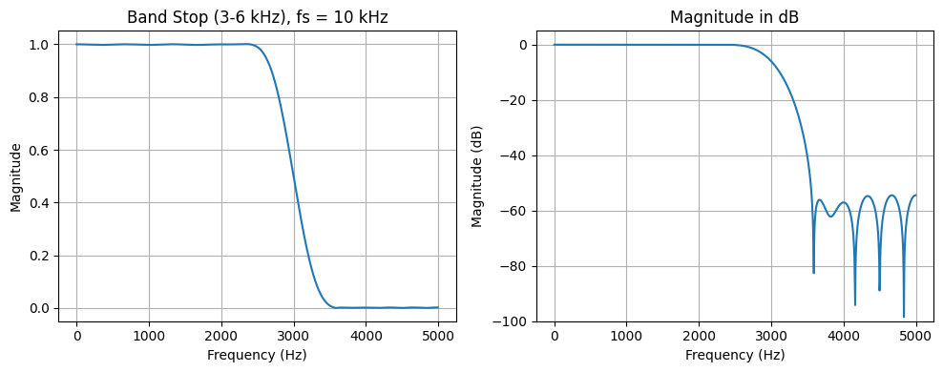

# fs = 20 kHz : both cutoffs 3 kHz and 6 kHz are valid
fs2 = 20000
h_bs2 = firwin(N, [3000, 6000], fs=fs2) # pass_zero=True gives band stop

print("Filter coefficients (fs = 20 kHz):")
print(np.round(h_bs2, 4))

plot_response(h_bs2, fs2, 'FIR Band Stop Filter (3-6 kHz), fs = 20 kHz')

Output:-
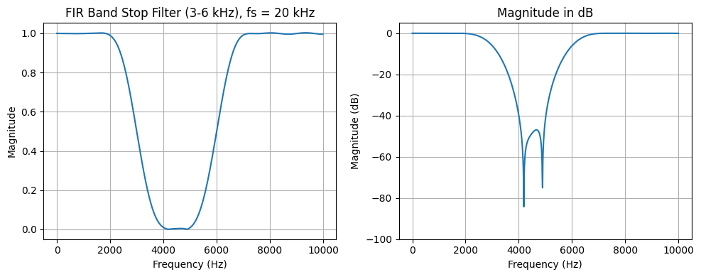

Observations:-
Low pass filter: The gain is 1 (0 dB) in the pass band up to about 2 kHz and falls to 0.5 (-6 dB) at the cutoff of 3 kHz. Above 4 kHz the attenuation is more than 54 dB. The coefficients are symmetric, so the filter has linear phase.
High pass filter: The gain is about 0 at low frequencies (more than 58 dB attenuation below 2 kHz), is 0.5 (-6 dB) at 3 kHz and becomes 1 (0 dB) at 4 kHz and above up to 5 kHz.
Band pass filter: With fs = 10 kHz the response is the same as the high pass filter, because 6 kHz is above the Nyquist frequency of 5 kHz. With fs = 20 kHz the filter passes the band between 3 kHz and 6 kHz with a gain of -6 dB at both cutoff frequencies. The attenuation outside the band is about 40 dB or more.
Band stop filter: With fs = 10 kHz the response is the same as the low pass filter. With fs = 20 kHz the filter passes the low and high frequencies with gain 1 and rejects the band between 3 kHz and 6 kHz, with a gain of -6 dB at both cutoff frequencies. Near the edges of the stop band the attenuation is only about 16 dB, and it increases to about 48 dB at the centre (4.5 kHz).
Because N = 31 is small, the transition between the pass band and the stop band is not sharp (about 1 kHz wide). Increasing N gives a sharper transition.

Conclusion
FIR low pass, high pass, band pass and band stop filters were designed with the window method using 31 coefficients, and their frequency responses were plotted. All the filters have symmetric coefficients and therefore linear phase. With a sampling frequency of 10 kHz the cutoff frequencies must be below 5 kHz, so the band pass and band stop filters with a 6 kHz cutoff need a sampling frequency above 12 kHz.

